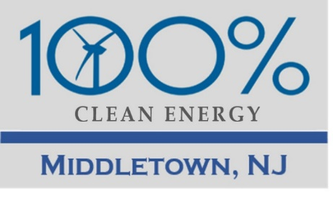
Middletown for Clean Energy Meeting with Mayor Tony Perry Feb 13, 2019 v4
2019 Update: We met with you early last year and talked about the risks of the impending climate crisis. Since then there have been a lot of developments at the town, state, and international level. We have learned a lot and would like to update you on our vision for Middletown.
- 3-minute video “Mayors for Climate” from last Feb NJ Mayors’ Climate Summit at Rutgers, sponsored by Sustainable Jersey. Several NJ towns have made impressive strides on the path to clean energy and sustainability. We can do this.
- Background: UN Intergovernmental Panel on Climate Change (IPCC) report, Oct 2018, National Climate Assessment, Nov 2018, Yale Climate Opinion Maps, Aug 2018
- 21 states, including NJ, have joined the U.S. Climate Alliance, working to uphold the terms of the Paris Climate Accord. Students in Europe are striking. A U.S. student climate action is scheduled for Mar 15.
- Our MCE Vision: Our legacy of a town (and world) where our children and grandchildren can flourish (i.e., leave it better than we found it)
- Our MCE Mission: Make Middletown a leader among NJ towns in committing to and achieving 100% Clean Energy by 2050. Since Middletown is the largest town in Monmouth County, other towns will follow.
- MCE Vision letter with benefits and requested actions
  - Issue a Mayor’s Pledge and Committee Resolution to move to 100% renewable electricity by 2030 and to achieve net-zero greenhouse gas (GHG) emissions in all sectors by 2050. With either action, we will arrange for press coverage, as in New Brunswick.
  - Update the Middletown Master Plan to include a Green Buildings and Environmental Sustainability Element.
  - Update the Middletown Energy Master Plan (consistent with the forthcoming NJ 2019 Energy Master Plan).
  - Implement Green Team Gold Star Standard in Energy.
- The Green Team needs to be given an explicit charge to pursue Sustainable Jersey Actions. We have heard them ask the Committee to support particular endeavors, without getting definitive answers. This has hindered progress.
- We hope to hear some progress on our request to apply for grants for EV charging stations (as requested by the Green Team Oct 2, 2017 and Dec 24, 2018, by letter from Steve and Pat Miller).
- The Sustainable Jersey Summit will be held at BELL WORKS, Holmdel, all day Friday, Jun 14.

